Chapter 1 – Introduction to LLMs and LangChain
Course: Prompt Engineering using LangChain
Course Overview:
- The course teaches how to use Large Language Models (LLMs) like ChatGPT or open-source models in your own apps or projects.
- It explains how people started using ChatGPT to write messages or automate actions.
- Later, open-source LLMs allowed developers to integrate these models directly into their systems.
- The course is for learners who know basic Python and want to build AI-powered ideas.
- It focuses on practical skills, not deep theory — helping you understand how to use and integrate these tools effectively.
- What is Machine Learning (ML)?
Machine Learning means teaching computers to learn from data and imitate human decision-making.

Main Stages of ML:
- Data Collection: Gather data. The better the data quality, the better the results.
- Model Training: The system learns patterns from the data.
- Model Usage: The trained model is used to make predictions or decisions.
Supervised Learning:
Uses labeled data (data organized by humans).
Example:
News labeled as Sports, Economy, Arts → the model learns to classify new headlines.
“Supervised” means humans guided the process by labeling the data.

Importance of Data Quality:
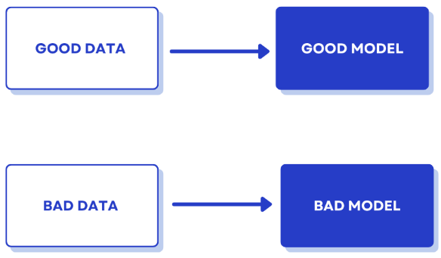
The model learns by comparing its predictions to correct answers, calculating errors, and improving over time — similar to human trial and error.

2. Base vs Instruction-Tuned LLMs

Base Language Model:
- A Language Model predicts the next word in a text sequence.
Example: If you type “السلام عليكم ورحمة الله”, it predicts “وبركاته.”
- Trained on massive raw text (internet, books, Wikipedia).
- Learns only how text flows — not how to answer questions.
- It can write grammatically correct text but may not follow instructions properly.

Instruction-Tuned LLM:
Trained again with instruction data (human-written question–answer pairs).
Example:
  - User: “What is the depth of the Atlantic Ocean?”
  - Expert: “The average depth is about 3,646 meters.”
This makes the model capable of understanding real instructions and producing clear, relevant answers.

Summary:
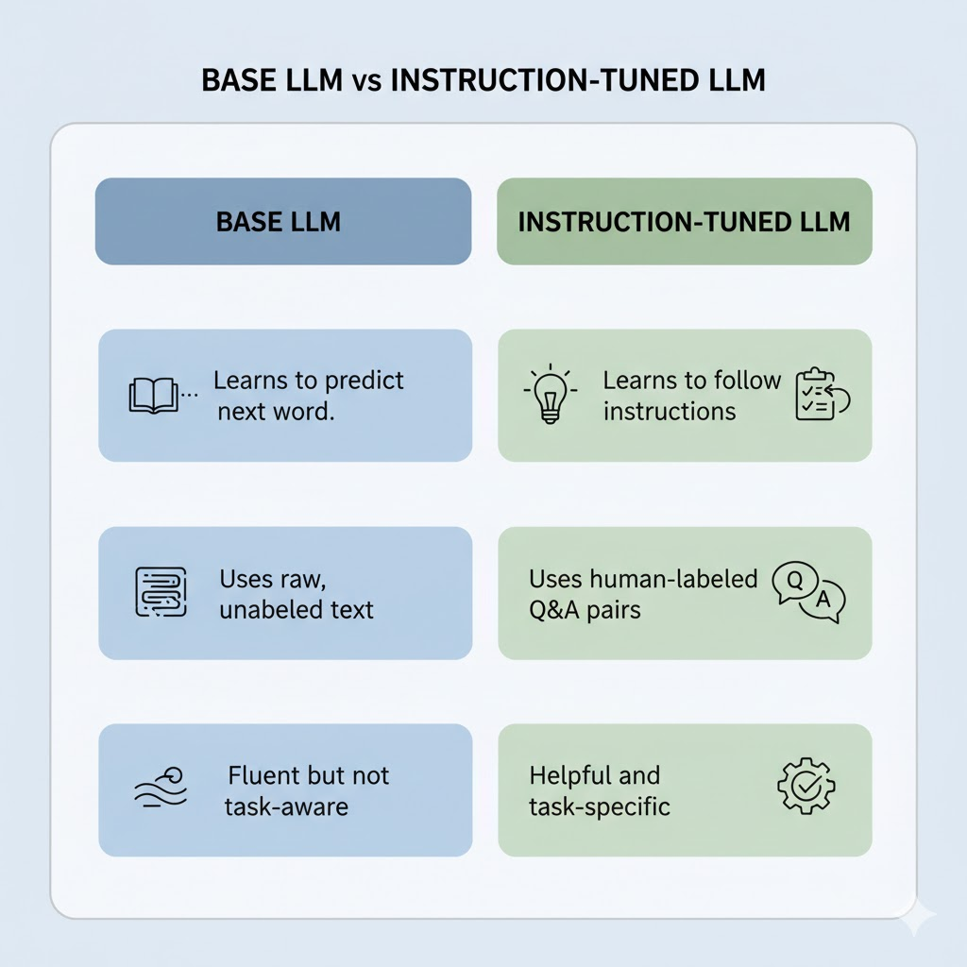

3. Tokenizers

A Tokenizer is a key part of every LLM.
It converts text into numbers that the model can understand.

Vocabulary and IDs
- Each model has a vocabulary: a list of words or parts of words, each with a unique ID number.
- The model only understands numbers, not text.
- Tokenizer = text → numbers
- Decoder = numbers → text

Encoding and Decoding:
- Encoding: Converts text into tokens (numbers).
Example:
  - “once” → 1002
  - “open” → 783
- Decoding: Converts tokens back into readable text.

How Tokenization Works:
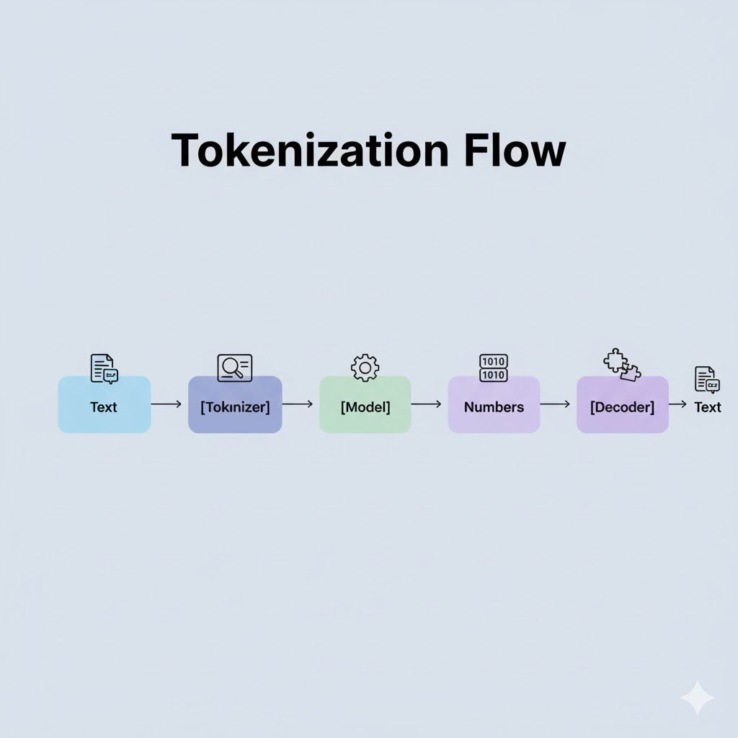

Why Tokenization Matters:
- Input length: 10 words may become 20–30 tokens depending on the language.
- Cost: LLM APIs charge per token.
- Performance: More tokens = slower processing.
- Non-English languages (like Arabic) often produce more tokens per word.
In short Tokenizers control how LLMs read, generate, and price text. They directly affect speed, cost, and efficiency.

4. Why LangChain
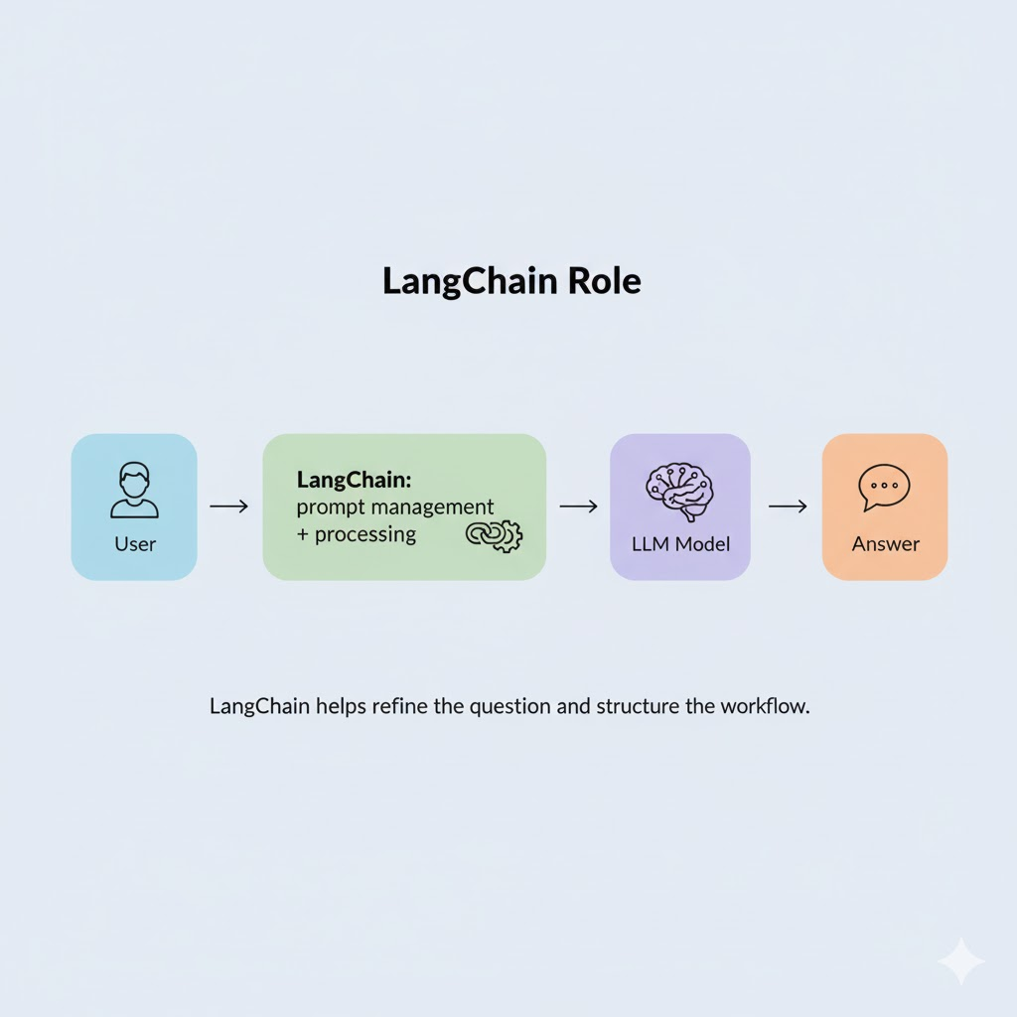
- Sometimes, the issue is not with the model but with how the question is written.
- LangChain helps structure and manage prompts before sending them to the model.
- It can:
  - Rephrase or improve your prompt.
  - Adjust the task automatically.
  - Process or refine the model’s response.
- It helps developers integrate LLMs into real applications more effectively.
- The course will teach how to use LangChain with ChatGPT and open-source models, and how to connect it to your apps.

